SDLC-Based Estimation,Scheduling, and Feasibility Analysis for a Budget- Constrained Sightseeing System

Day 1:
Departure from Salem
Salem to Bangalore : 1am to 6am(Train-Mysuru express)
Per person : Rs.500
For 10 : Rs.5000
To airport-taxi
Bangalore to Bagdogra : 7.20am to 10am(Aeroplane-Air India Express)
Per person : Rs.6250(With food)
For 10:Rs.62,500
Bagdogra to Darjeeling : 1pm to 3pm(NJP APDJ tourist train)
Per person : Rs.270
For 10 : Rs.2700
Darjeeling railway station to Nuzong lee home stay:3.20pm to 3.30pm(Taxi)
Per taxi : Rs.1500
Two taxi : Rs.3000

Nuzong lee home stay
Per day per person(veg) : Rs.1500
Per day per persona (non veg) : Rs.1800
For 7 non vegetarians : Rs.12600
For 3 vegetarians : Rs.4500
For 10 person : Rs.17100

Total stay fee for 3 days:
Per day per person(veg) : Rs.1500
Per day per person(non veg) : Rs.1800
For 10 person per day : Rs.17100
For 10 person 3 days : Rs.51300

Day 2:
Mode of transport : Tempo(per day :Rs.5500)
Nuzong lee home stay to tiger hills:(13 KM-1 hours)
Requires a very early start (3:30 AM - 4:00 AM from Darjeeling) to catch the sunrise. Entry is ₹50, with extra charges for the tower.
Per persona: Rs.50
For 10 : Rs.500
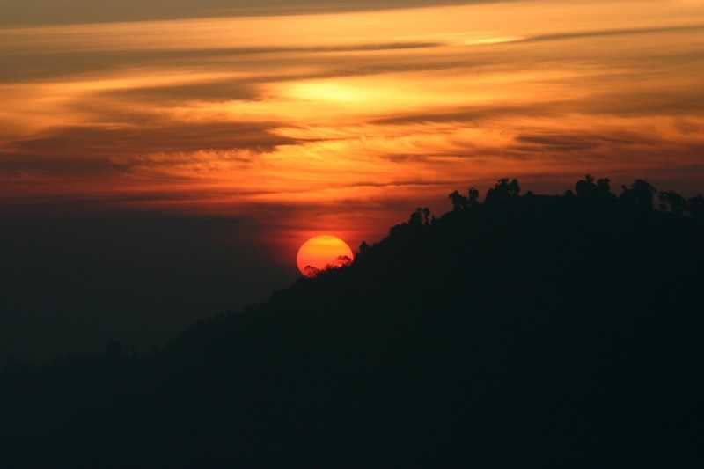
All 10 members should wake up at 3:30 AM in the hotel.We will start our journey by 4.30 after getting ready for 1hour.Then we will travel by car to Tiger Hill and reach there by 6:30 AM.We can spend about 1 hour at Tiger Hill by watching the sunrise.At around 8:30 AM, we will go to a nearby hotel for breakfast.
Breakfast will be completed before10:30 AM.
Tiger hills to Ghoom(7.5 KM-23 minutes)
After that, at 11:15 AM, we will go to Ghoom,which is one of the oldest Tibeetian Buddhist monasteries and will spend 1 hour there, till 12:15 PM.
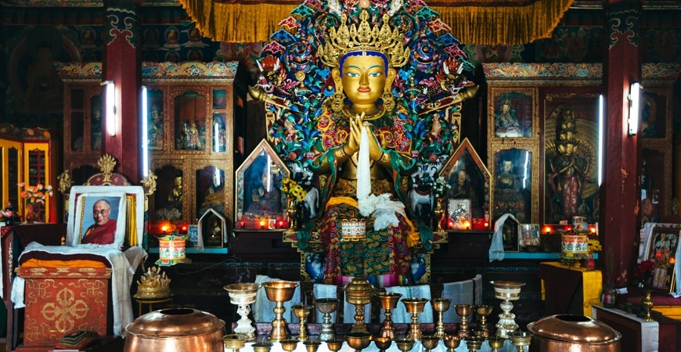

Ghoom to nuzong lee home stay (6.58KM)
Day one travel is completed and tourist can take complete rest.

Day 3:
By 9am ,We will have breakfast and by 9.30am we will start our journey to Peace Pagoda.
Tempo fee : Rs.5500

Nuzong lee home stay to Peace Pagoda(4KM -20minutes)
By 9.50 to 10am we will reach Peace Pagoda.
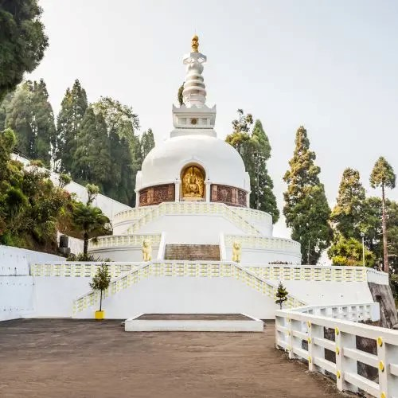

Peace Pagoda is a calm and spiritual place built to promote peace and harmony. Visitors can relax, spend quiet time, and enjoy wide panoramic views of Darjeeling town and the snow-covered Himalayan range on clear days.There we can spend 3 hours.

Peace pagoda to Batasia Loop(6KM-25minutes)
Maximum by 2pm we will reach Batasia loop.
For entry person : Rs.40
For 10: Rs.400
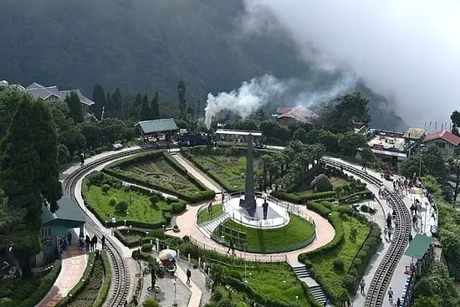

Batasia Loop is a famous spiral railway track where the Darjeeling toy train passes. From here, you can enjoy beautiful views of the mountains, colorful gardens, and the war memorial in the center.There we can spend about 3 hours.And we can start our journey to hotel by 5pm
Bataisa loop to Nuzong lee home stay(6KM-20minutes)
By 5.30pm we can reach hotel.After reaching hotel,tourist can take rest until next day morning.

Day 4:
Nuzong lee home stay to Himalayan mountaineering Institute:
(3Km-35minutes)
We will get ready by morning 9 am and we can have breakfast in hotel itself and start our journey to Himalayan mountaineering Institue by 9.20am in and we can reach there by 9.55am.
For per Person entry fare : Rs.100
For 10: Rs.1000
Himalayan Mountaineering Institute (HMI), where you learn about famous mountaineers, see Mount Everest expedition equipment, and visit the memorial of Tenzing Norgay and experience mini adventureous acitivities like rock climbing.We can spend about 2 hours there.
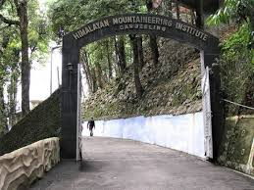

Himalayan mountaineering Institue to Padmaja naidu Himalayan zoological park(0.5KM-5minutes)
Starting our journey by 12noon and we can reach padmaja naidu Himalayan zoological park by 12.10am.
The Padmaja naidu Himalayanam zoological park is known for its unique high altitude animals is renowned for conservation efforts and Asian endangered species.We can spend 2 hours there.
Famous for Red Panda
Snow Leopard, Himalayan Wolf
High-altitude animals in natural habitat
Clean, well-maintained zoo
Per persona ticket fare:Rs.110
For 10:Rs.1100

Padmaja naidu Himalayan zoological park to Tea estates(2.1KM-15minutes)
From there we will start our journey by 2.10pm and will reach Tea estate by 2.25pm.

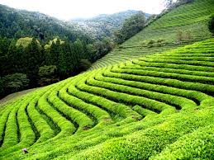

Happy Valley Tea Estate, where you walk through green tea gardens, watch how tea leaves are processed, and taste fresh Darjeeling tea while enjoying the scenic views.There we can spend hour.And start our travel to Mall road again.
Tea estates to Mall road(3 to 4KM – 15 minutes)
We can reach mall road by 3.45pm. Mall Road (Chowrasta), which is the heart of Darjeeling, where you shop for souvenirs, try local snacks, sit on benches, and enjoy the cool breeze and crowd.We can do shoppint until 8 to 9pm.
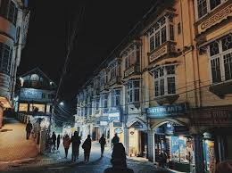

Then we can easily return to our hotel as it is located in Mall road.

Day 5:
Return to Salem:
We sound wake up early morning by 6.30am and get ready for taxi to reach railway station by 8am.
Nuzong Lee Homestay to Bagdogra Airport(95KM to 96KM)
Time: 7:00 AM – 11:00 AM
Mode: Taxi / Sumo / Maxx (Local Hill Taxi)
Cost:
Per taxi: ₹3,500 (approx)
Two taxis (for 10 members): ₹7,000.
Bagdogra to Bangalore(2424KM-Aeroplane)
Bagdogra to Bangalore
Time: 1:30 PM – 4:45 PM
Mode: Aeroplane (IndiGo / Air India Express)
Cost (with food, approx):
Per person: ₹6,500
For 10 persons: ₹65,000
Bangalore to salem(185KM)
Time: 11:30 PM – 5:30 AM
Mode: Train (KSR Bengaluru → Salem Express / Mysuru–Tuticorin Express)
Cost:
Per person: ₹300
For 10 persons: ₹3,000
Budget plan and estimation
Day 1:
Salem to Bangalore (train-vande bharat): Rs.9400
Bangalore to Bagdogra (flight) : Rs.62500
Bagdogra to Darjeeling(train) : Rs. 2700
Darjeeling railway station to hotel : Rs. 3000

Day 2:
Tiger hill entry fee : Rs. 500
Break fast in nearby hotel : Rs.2500
Ghoom entry fee : Free

Day 3:
Pagoda Peace entry fee: free
Batasia loop entry fee : Rs. 400

Day 4:
Himalayan mountaineering Institute entry fee : Rs.1000
Padmaja naidu zoological park entry fee : Rs.1100
Tea estate : Rs. 2000
Shopping : Personal cash
Taxi over all for 3 days: Rs.30000

Day 5:
Taxi from nuzong lee home stay to bagdogra airport : Rs.7000
Bagdogra to Bangalore (flight) : Rs.65000
Bangalore to Salem (train ): Rs.3000

Total cost :2,36,000

